
Name: Ajayi Oluwapelumi Joseph
Matriculation Number: AUL/CMP/22/013
Course Code: CMP 417
Course Title: Database Management II

Define distributed database and discuss the different types of transparency in distributed databases

Definition of a Distributed Database

A distributed database is a single logical database that is dispersed physically over a number of geographically located computers that are linked together through a data communications network. From the users' point of view, it appears to be a single, coherent database, but in fact the data will be distributed across many sites and maintained independently on different computers, (known as sites or nodes).

Each site will maintain its own local database, local DBMS and yet they will co-operate together in maintaining the global database. The main feature being that the system manipulates distributed data without any noticeable differences to the user.

Transparency in Distributed Databases
Transparency in a distributed database system is the hiding of the distribution of data among sites and the underlying structure and mechanics of the distributed system itself. Essentially, transparency allows a user to treat the distributed database as a single monolithic centralized database and not need to worry about the how and where the data is physically stored.

Types of Transparency
The purpose of transparency is to hide the distribution of the database from the user. A DDBMS may aim to support the following types of transparency:

A. Fragmentation Transparency
This is the highest level of transparency. Transparency means that the user is not aware of the data fragmenting (partitioning) into multiple fragments. The user can query table as an entirety and the system do the work of aggregating fragments.
The image below illustrates this concept:
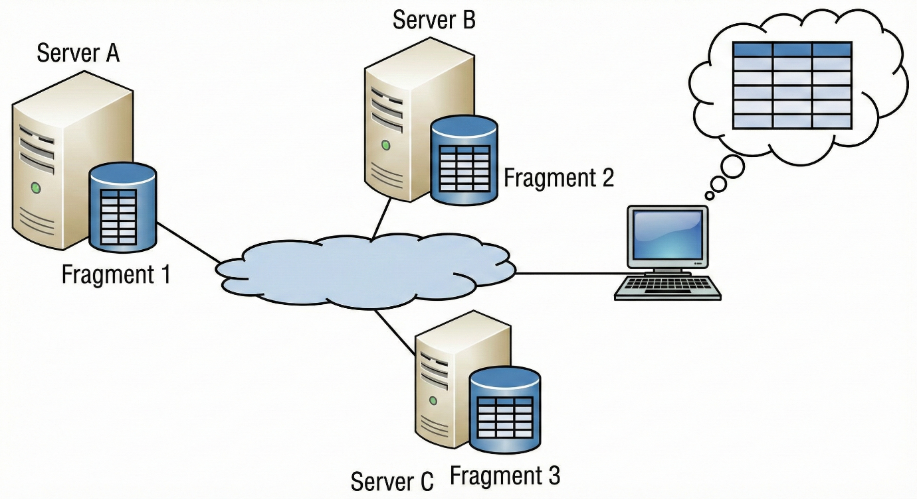
Explanation of Image:
- The user at the computer perceives a single, complete database table (the thought bubble).
- In reality, the table is split into three fragments (Fragment 1, Fragment 2, and Fragment 3), each stored on a different server (Server A, Server B, and Server C).
- The distributed system manages these fragments, making their existence transparent to the user.

B. Replication Transparency
This involves the user not knowing that data exists on multiple sites. The consistency between the multiple copies of data will be managed automatically by the system. The user does not need to choose a particular replica to query data from, but rather the system can pick the most suitable copy for query performance and reliability reasons.
The following image shows replication transparency in action:
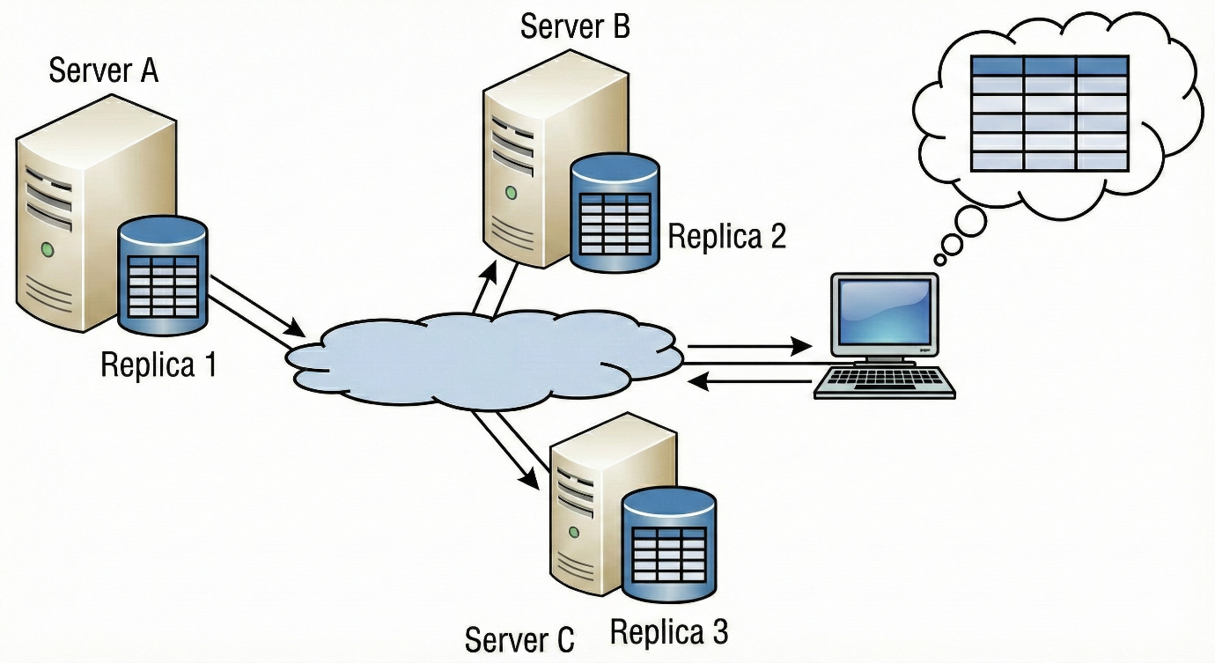

Explanation of Image:
- The user still sees a single logical database.
- Each server (A, B, and C) now holds a full copy (replica) of the data.
- The user makes a request to the network, and the DDBMS routes the request to one of the servers (e.g., Server B, as shown by the arrows).
- The user does not know or care that there are multiple copies; they just get their data.

C. Location Transparency
Data location transparency means that the user doesn't need to know the physical storage site of data. A user request is presented without the physical storage site. The DDBMS finds the required data at that site and retrieves it.
The image below illustrates this:
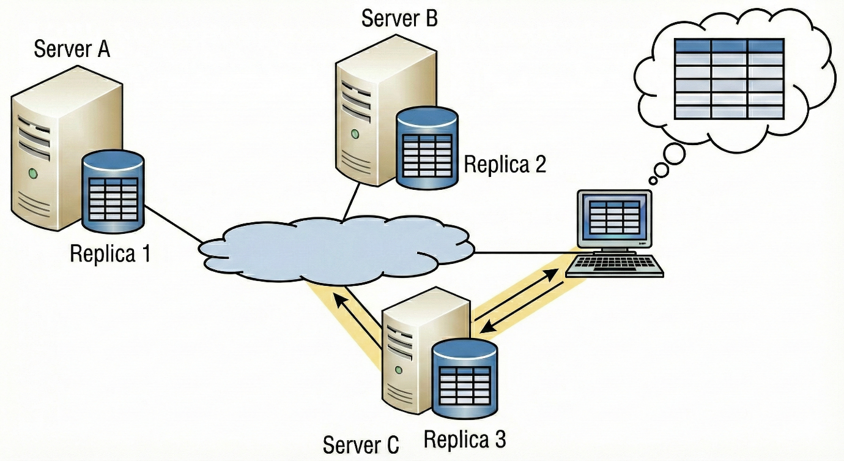

Explanation of Image:
- The user queries the system for some data.
- The DDBMS determines that the required data is on Server C.
- The data is retrieved from Server C and sent to the user (highlighted path).
- The user's screen shows the data, but the user has no idea it came from a specific location (Server C).
The distributed database is a strong and powerful system that saves data in distributed form but gives a view to the user that as if data is stored in a single site. Fragmentation, Replication and Location are the types of transparency features which cover-up the distributed form of the system, making it a simple and manageable system. All the type of transparency features is pictorially shown by the above images.

References
https://www.oracle.com/africa/database/distributed-database/what-is-distributed-database/
https://www.mongodb.com/resources/basics/databases/distributed-database
https://www.geeksforgeeks.org/dbms/distributed-database-system/
https://www.designgurus.io/answers/detail/what-is-transparency-in-a-distributed-system#:~:text=The%20goal%20is%20to%20provide,to%20understand%20its%20distributed%20nature.
https://www.scribd.com/presentation/684681959/Unit-1-Transparency-in-DDBMS
https://www.oracle.com/database/distributed-database/what-is-distributed-database/
https://sis.binus.ac.id/2021/03/10/transparencies-in-dbms/
https://www.enterprisedb.com/blog/what-is-a-distributed-database
https://en.wikipedia.org/wiki/Location_transparency

